
Lab Assignment: 02
Course: Information Security
Submitted to: Mam Ambreen
Submitted by: Attiqa
Reg no: Sp24-bse-050
Oct 12, 2025

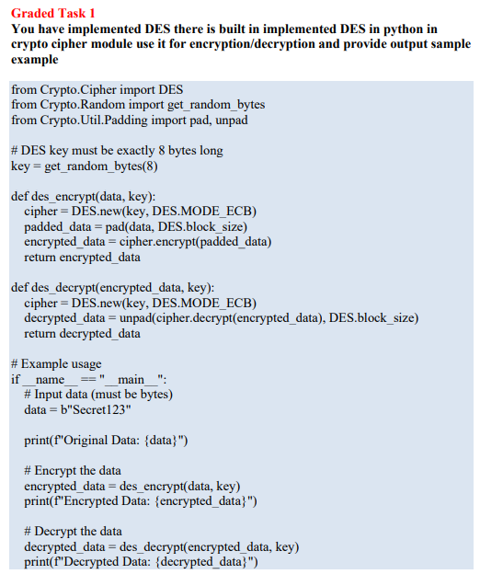

OUTPUT:
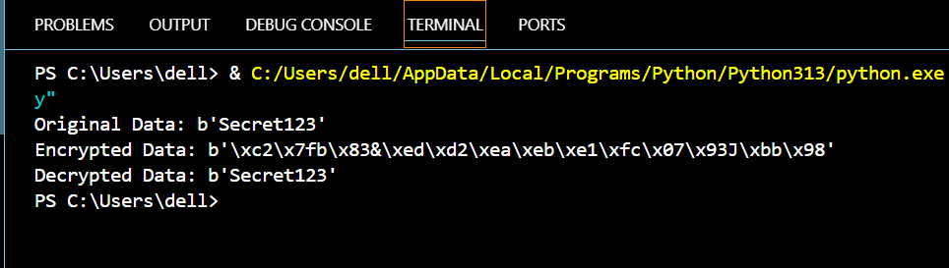
CODE Explanation:

Short summary
This program demonstrates DES encryption and decryption using PyCryptodome’s built-in DES cipher. It generates a random 8-byte key, pads the input to DES’s 8-byte block size, encrypts the padded plaintext in ECB mode, and then decrypts and unpads the ciphertext to recover the original plaintext. The program prints the original data, the encrypted bytes, and the decrypted result to show that encryption and decryption work correctly.

2) Line-by-line / block explanation
from Crypto.Cipher import DES
from Crypto.Random import get_random_bytes
from Crypto.Util.Padding import pad, unpad
- Imports:
  - DES — the DES block cipher implementation.
  - get_random_bytes — generate cryptographically secure random bytes (used for the key).
  - pad / unpad — helpers to add and remove PKCS#7-style padding so data matches DES block size.
# DES key must be exactly 8 bytes long
key = get_random_bytes(8)
- Key generation: DES requires an 8-byte key (64 bits). In DES eight bits are used for parity, giving an effective security key size of 56 bits. This line creates a random 8-byte key for one run of the program.
def des_encrypt(data, key):
cipher = DES.new(key, DES.MODE_ECB)
padded_data = pad(data, DES.block_size)
encrypted_data = cipher.encrypt(padded_data)
return encrypted_data
- des_encrypt(data, key):
  - DES.new(key, DES.MODE_ECB) creates a DES cipher object in ECB (Electronic Codebook) mode.
  - pad(data, DES.block_size) pads the input so its length is a multiple of DES block size (8 bytes). Padding is required because DES encrypts fixed-size blocks.
  - cipher.encrypt(padded_data) encrypts the padded bytes and returns ciphertext bytes.
  - The function returns the ciphertext.
def des_decrypt(encrypted_data, key):
cipher = DES.new(key, DES.MODE_ECB)
decrypted_data = unpad(cipher.decrypt(encrypted_data), DES.block_size)
return decrypted_data
- des_decrypt(encrypted_data, key):
  - Recreates the DES cipher with the same key and mode.
  - cipher.decrypt(encrypted_data) decrypts the ciphertext bytes to produce the padded plaintext.
  - unpad(..., DES.block_size) removes the padding and returns the original plaintext bytes.
  - The function returns the decrypted (unpadded) plaintext.
# Example usage
if __name__ == "__main__":
# Input data (must be bytes)
data = b"Secret123"

print(f"Original Data: {data}")
- Main block: When you run the file directly this block executes. data = b"Secret123" defines the plaintext (bytes). The code prints the original data. (To complete the example you should call des_encrypt and des_decrypt and print their outputs — see sample full usage below.)

3) Complete example (how to use the functions
Add these lines inside the if __name__ == "__main__": block to show encryption and decryption:
# Encrypt the data
encrypted_data = des_encrypt(data, key)
print(f"Encrypted Data (hex): {encrypted_data.hex()}")

# Decrypt the data
decrypted_data = des_decrypt(encrypted_data, key)
print(f"Decrypted Data: {decrypted_data}")
This will print the ciphertext in hex (readable) and the recovered plaintext.

Graded Task 2:
Visualization of MITM Attack Flow: Attacker intercepts plaintext (P) and ciphertext (C) 1. Guess K1 P --[Encrypt with K1]--> Intermediate Value 1 (I1) 2. Guess K2 C --[Decrypt with K2]--> Intermediate Value 2 (I2) 3. If I1 == I2, then K1 and K2 are likely correct. Found the DES key: K = K1 + K2
A MITM attack on double DES tries every possible first key K1K_1K1​ to get intermediate values from the known plaintext, stores them, then tries every possible second key K2K_2K2​ to decrypt the ciphertext and looks for matches — matching intermediate values reveal likely (K1,K2)(K_1,K_2)(K1​,K2​).

Assumptions
Attacker has at least one known plaintext–ciphertext pair (P,C)(P, C)(P,C).
- Target uses double DES: C=EK2(EK1(P))C = E_{K_2}(E_{K_1}(P))C=EK2​​(EK1​​(P)).
- DES operations can be split so that encryption with K1K_1K1​ and decryption with K2K_2K2​ produce the same intermediate value when keys are correct.
- Attacker can store a table of size up to about 2562^{56}256 entries (practical constraints aside).

Complexity (time & memory)
- Key space per DES key: 2562^{56}256 (56-bit DES key).
- Time complexity: ≈ 256+256=2572^{56} + 2^{56} = 2^{57}256+256=257 DES operations (one pass encrypting for all K1K_1K1​, one pass decrypting for all K2K_2K2​). We usually say about 2572^{57}257 operations.
- Memory: store about 2562^{56}256 intermediate values (table entries). So memory ~ proportional to 2562^{56}256 entries (each entry stores an intermediate block (64 bits) + a key — large in practice).
- Practical note: 2562^{56}256 entries is huge; real attackers use time–memory tradeoffs, parallelization, or optimized storage. This is why double DES is not as secure as you’d think.

Why MITM breaks “double” encryption
- Double DES EK2(EK1(P))E_{K_2}(E_{K_1}(P))EK2​​(EK1​​(P)) naively looks like 2×56=1122 \times 56 = 1122×56=112 bits of security, but MITM reduces the effective work to only about 2572^{57}257, far less than 21122^{112}2112. That’s why Triple DES (3DES) was designed differently (EDE) to avoid this weakness.

Dealing with false positives
- One plaintext–ciphertext pair often yields many candidate pairs due to collisions and chance matches.
- Use 2 or more known (P,C) pairs: only the correct (K1,K2)(K_1,K_2)(K1​,K2​) will correctly encrypt all pairs. So verify every candidate against extra pairs.
- If you still have multiple verified candidates (unlikely if you use enough pairs), you can test ciphertexts of longer messages or test decrypting a known structured header.

